Laboratory Equipment Reference Sheet:

Iron Ring:
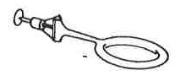
Description: Iron ring with a screw fastener; Several Sizes
Uses: To fasten to the ring stand as a support for an apparatus

Buret Clamp/Test Tube Clamp:
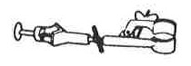
Description: Metal clamp with a screw fastener, swivel and lock nut, adjusting screw, and a curved clamp.
Uses: To hold an apparatus; May be fastened to a ring stand.

Mortar and Pestle:
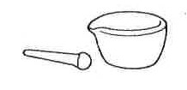
Description: Heavy porcelain dish with a grinder.
Uses: To grind chemicals to a powder.

Spatula:
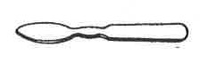
Description: Made of metal or porcelain.
Uses: To transfer solid chemicals in weighing.

Triangular File:
Description: Metal file with three cutting edges.
Uses: To scratch glass or file.

Rubber Connector:
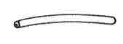
Description: Short length of tubing.
Uses: To connect parts of an apparatus.

Pinch Clamp:
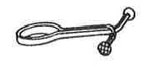
Description: Metal clamp with finger grips.
Uses: To clamp a rubber connector.

Test Tube Rack:
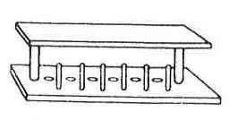
Description: Rack; May be wood, metal, or plastic.
Uses: To hold test tubes in an upright position.

Plastic Wash Bottle:
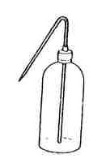
Description: Squeezable plastic bottle with angular tip.
Uses: To dispense distilled water.

Test Tube Brush:
Description: Brush with a wire handle.
Uses: To scrub glass apparatus.

Stirring Rod:
Description: Glass rod.
Uses: To stir combinations; To use in pouring liquids.

Evaporating Dish:
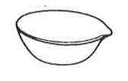
Description: Porcelain dish.
Uses: As a container for small amounts of liquids being evaporated.

Glass Plate:

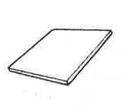
Description: Thick glass.
Uses: Many uses; Should not be heated

Watch Glass:
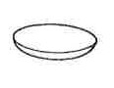
Description: Curved glass.
Uses: May be used as a beaker cover; May be used in evaporating very small amounts of liquid.
Funnel:
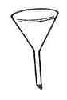
Description: Glass or plastic.
Uses: To hold filter paper; May be used in pouring

Medicine Dropper:
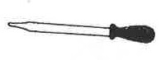
Description: Glass tip with a rubber bulb.
Uses: To transfer small amounts of liquid.

Forceps:
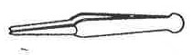
Description: Metal
Uses: To pick up or hold small objects.

Beaker:
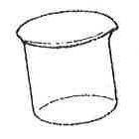
Description: Glass; Common sizes are 100 mL, 250 mL, 400 mL; Size is marked.
Uses: As a container, like a cup; May be heated.

Graduated Cylinder:
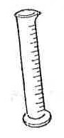
Description: Glass or Plastic; Marked with a milliliter (mL) scale).
Uses: To measure volume.

Erlenmeyer Flask:
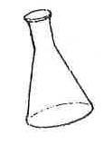
Description: Glass; Common sizes are 125 mL, 250 mL, 500 mL; Size is marked.
Uses: May be heated.

Florence Flask:
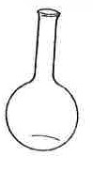
Description: Glass; Common sizes are 125 mL, 250 mL, 500 mL; Size is marked.
Uses: May be heated.

Test Tube:
Description: Glass; Several Sizes.
Uses: Many uses; May be heated.

Test Tube Holder:
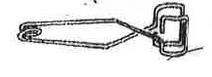
Description: Metal; Clamp with a spring handle.
Uses: To hold a test tube.

Tongs:
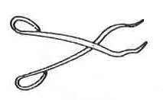
Description: Metal.
Uses: To pick up and hold an apparatus.

Ruler:
Description: Divided into centimeter and millimeter divisions.
Uses: To measure length.

Clay Triangle/Pipestem Triangle:
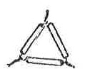
Description: Triangular wire frame with clay material coverings.
Uses: To support a crucible.

Crucible and Cover:
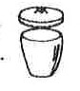
Description: Small porcelain dish with a cover.
Uses: To heat small amounts of solid material at a high temperature.

Wire Gauze:
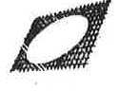
Description: Wire screen with ceramic-fibered center.
Uses: To spread the head of a flame.

Laboratory Burner/Bunsen Burner:
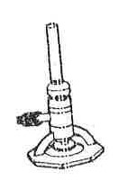
Description: Metal heating device connected to a gas outlet with rubber tubing.
Uses: To heat chemicals in beakers or test tubes.

Laboratory Safety Goggles:

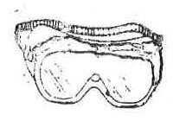
Description: Close-filling eyeglasses with side shields Uses: For protecting eyes from chemicals used in lab.

Ring Stand:
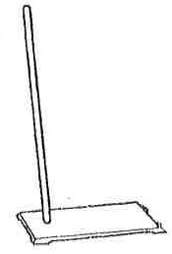
Description: Metal rod upright with a heavy base.
Uses: A support with many uses.

Buret:
Description: Glass; Marked with a milliliter (mL) scale and filled with a stopcock, pinch clamp, or glass bead.
Uses: To withdraw and measure volumes of solutions in titrations.

Volumetric Flask:
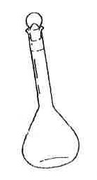
Description: Glass; Marked off to liter capacity with a glass stopper.
Uses: Used in the preparation of solutions.

